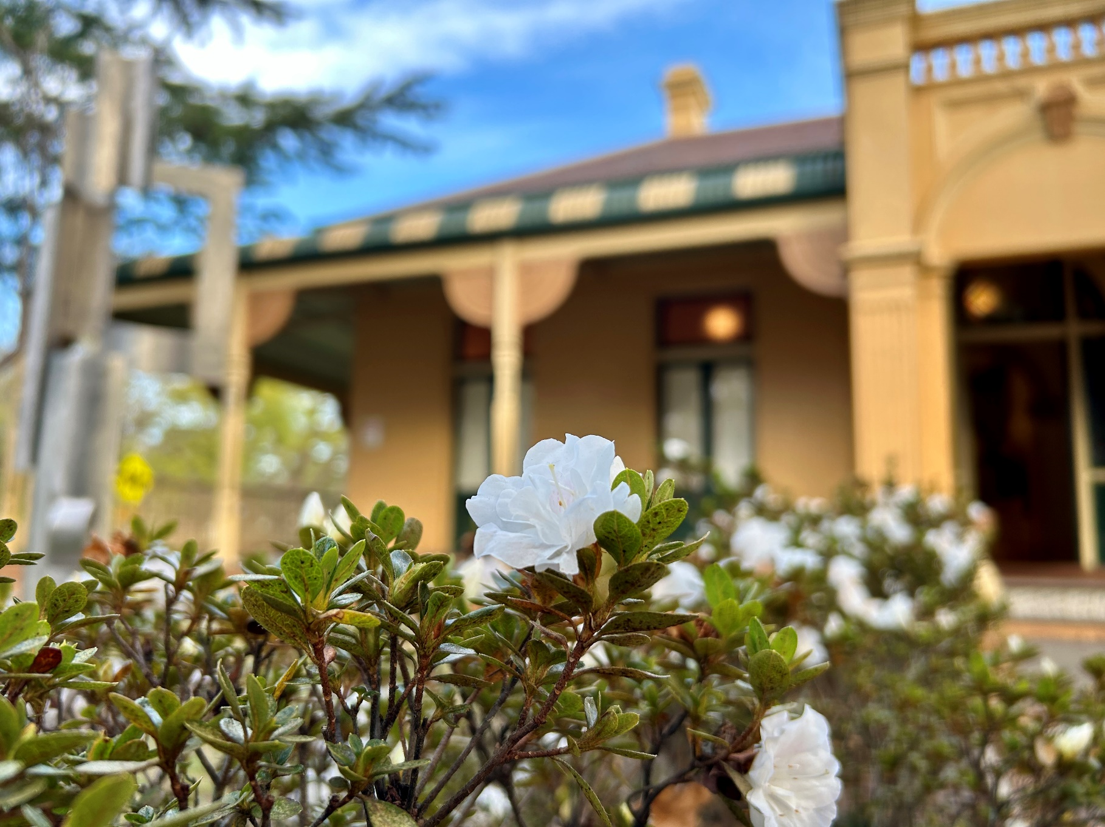

Braemar Gallery
2026 Exhibition Program
Application Form




2026 Open Call Key Dates
- Applications open Friday 22 August 2025
- Info / help session 5.30pm Thursday 11 September 2025 (at Braemar House)
- Applications close 11.59pm Wednesday 1st October 2025
- Program announced November
What are the criteria for applying?
The annual exhibition program is open to Blue Mountains artists who are interested in presenting a solo exhibition, or to Blue Mountains artist groups or collectives interested in presenting an exhibition together.
Artists residing in local government areas directly adjoining to the Blue Mountains (Penrith, Hawkesbury and Lithgow) will be considered, however they must address one of the following criteria in their application:
- demonstrate a connection to the Blue Mountains; or
- how their exhibition will offer a benefit to Blue Mountains residents.
All artists require availability to attend their exhibition installation, opening event and deinstall, as well over the course of their exhibition.
All applications will be assessed by the Braemar House Reference Group against the following criteria:
- Does the exhibition demonstrate artistic merit and originality? 40%
- Is the exhibition concept clear and concise? 20%
- Has the artist considered how the exhibition communicates to its intended audience? 20%
- Are there adequate support materials, including images and the artist’s resume, to assess the proposal? 20%
If individual artists or groups of artists have exhibited in 2025/2026, they are required to wait a year before applying again. This does not apply to solo artists who have artists in a group exhibition.
The Reference Group reserves the right to refuse applications from exhibitors and/or community groups.
Applicants are urged to view the spaces at Braemar Gallery prior to lodging their applications. A map with the dimensions of the three Gallery Rooms (A, B & C) is available.
How to apply for 2026 Braemar Gallery Exhibition Program
- All applications to exhibit at Braemar Gallery must use this Application Form and be submitted by 11.59pm on Wednesday 1 October 2025.
- Applications that do not adhere to the Application Form will be rejected. Partially completed applications will not be assessed.
- We ask applicants to prepare their application as follows:
- Download this Word Application Form and answer each question using the existing formatting (Myriad Pro, size 11 font etc) and keeping to the prescribed word limits.
- Save the document as a PDF, attached the PDF and support materials to an email and send it to braemargallery@gmail.com. Please put “2026 Exhibition Program Application” followed by your name in the email subject line.
- Email is our preferred method for receiving applications. However, you may post your application with images on USB to the below address:
Braemar House Reference Group
C/o Cultural Development Officer
Blue Mountains Cultural Centre
Locked Bag 1005
KATOOMBA NSW 2780
Postal applications must be received by COB on Wednesday 1 October 2025. Please do not send original artworks.
- Please provide images as jpeg or pdf files. Images must be clearly numbered, corresponding to the list in the Application Form. Image size should be 200-300dpi and not exceed 3MB. Files may be zipped/compressed to reduce email size.
- Please ensure your application does not exceed 10MG.
Assistance with completing Application Form
If you have any questions or require support completing your Application Form, email braemargallery@gmail.com or phone 4780 5544. Please note the Braemar Gallery Officer works part time Wednesdays to Fridays.
Information and help session
There is also an information and help session at 5.30pm on Thursday 11 September at Braemar House. Please RSVP by emailing braemargallery@gmail.com.

APPLICATION FORM
Applicant Name/s (or Group Coordinator’s name if application is for a group exhibition)
Postal address
A reminder that applicants residing in local government areas directly adjoining to the Blue Mountains (Penrith, Hawkesbury and Lithgow) will be considered, however they must address additional criteria – see page 4.
Mobile phone
Email
Website (if applicable)

Exhibition name
Exhibition summary (maximum 75 words) Summarise the exhibition. This summary will be used for promotional purposes should your application be successful.
Exhibition description (maximum 300 words) Describe the proposed theme/concept and medium/s used. For community/group exhibitions this summary needs to outline the theme for the exhibition, participating artists, number and medium of works.
For applicants residing Penrith, Hawkesbury and Lithgow LGAs (maximum 200 words) Please demonstrate connection to the Blue Mountains; or; explain how your exhibition will offer a benefit to Blue Mountains residents.

How many rooms would you like? Please note that you may not be allocated the number of rooms you have requested. Solo artist exhibitions are usually allocated one room. | 1 ☐ 2 ☐ 3 ☐

Would you prefer your exhibition to be around a particular date or time of year? For example, an anniversary event or national week. Should your application be successful, the Reference Group will endeavor to schedule your exhibition at this time, but can not guarantee it will be possible.
Application checklist | ☐ I am a resident of the Blue Mountains LGA or resident in a local government area directly adjoining to the Blue Mountains (Penrith, Hawkesbury and Lithgow)  ☐ I have completed all parts of the Application Form including providing a CV for all artists and supporting artwork images.  ☐ My application does not exceed 10MB.  ☐ I have read and understood the 2026 Braemar Gallery Exhibition Program Guidelines  ☐ All artworks in my application are my own.
Signature Please use an electronic signature if possible or otherwise, print, sign and scan.
Date

Support Material

- Please list below details of the digital images provided with your application. These images can be of artwork you plan to include your exhibition or are indicative of what you are planning to create for your exhibition. Images can either be inserted into the table below, attached to the application email or uploaded to a USB and posted. A minimum of eight (8) and a maximum of ten (10) images are required for solo exhibitions, or up to five (5) images per artist but no more than twenty (20) in total for group/community exhibitions.

- Provide a CV relevant to your artistic practice (maximum of 2x A4 pages). In case of a group application please provide a paragraph bio or CV for each artist. The CV/s can be provided as a separate attachment to the application email.

Title, Artist and Artwork Image | Year | Medium/s | Dimensions  in cm  (h x w x d)
1. Example only – title, artist name
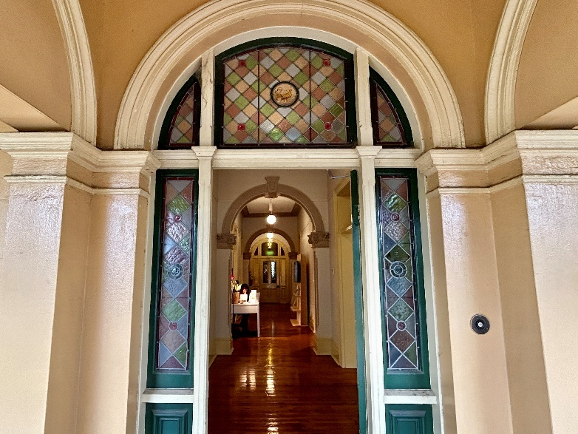
2.

3.

4.

5.

6.

7.

8.

9.

10.

