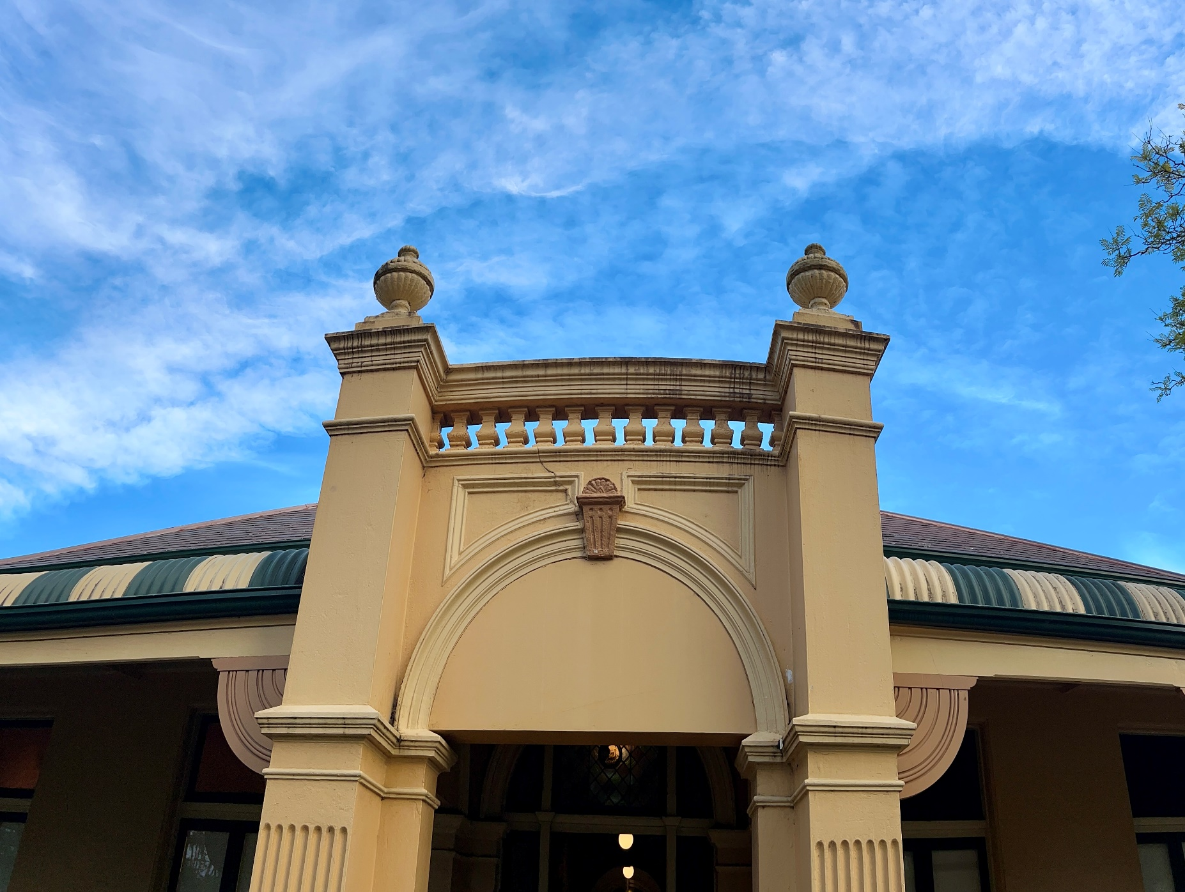

Braemar Gallery
2026 Exhibition Program
Guidelines for Applicants





APPLICATION GUIDELINES

Introduction
Blue Mountains City Council’s Cultural Development department coordinates programming at Braemar House. Braemar House is part of the Blue Mountains Theatre and Community Hub precinct. It is home to Braemar Gallery. Opened in 1988, Braemar Gallery is a community gallery, hosting changing exhibitions that showcase works of artists within the Blue Mountains local government area.
The aim of Braemar Gallery is to foster the development of visual arts in the Blue Mountains. The gallery presents an annual program of exhibitions from artists selected by the Braemar House Reference Group (Reference Group) which is composed of Councillors, Council staff and community members. Exhibitions are then coordinated by the Exhibitions Team and Marketing Coordinator. A Council Cultural Development Officer provides administrative support to the Reference Group and gallery operations.
The Reference Group runs an annual call for applications for the Exhibition Program at Braemar Gallery for the following year.
2026 Open Call Key Dates
- Applications open Friday 22 August 2025
- Info / help session 5.30pm Thursday 11 September 2025 (at Braemar House)
- Applications close 11.59pm Wednesday 1 October 2025
- Program announced November
Who can exhibit?
The annual exhibition program is open to Blue Mountains artists who are interested in presenting a solo exhibition, or to Blue Mountains artist groups or collectives interested in presenting an exhibition together.
Artists residing in local government areas directly adjoining to the Blue Mountains (Penrith, Hawkesbury and Lithgow) will be considered, however they must address one of the following criteria in their application:
- demonstrate a connection to the Blue Mountains; or
- their exhibition will offer a benefit to Blue Mountains residents.
If individual artists or groups of artists have already exhibited in 2025/2026, they are required to wait a year before applying again. This does not apply to solo artists who have participated in a group exhibition.
Group exhibitions
When submitting a group exhibition application, we encourage the applicants to think about a cohesive theme and that all group members respond to this theme.
Group exhibitions require a Group Coordinator to be appointed. The Group Coordinator is then responsible for managing all communications for group members including promotional information, installation information and volunteer duties such as roster reminders.
How is selection made?
In order to provide a fair and transparent process, applications will be assessed by the Braemar House Reference Group using the evaluation criteria listed on the following page.
The Reference Group reserves the right to accept or refuse exhibition applications at its discretion.

What are the criteria for applying?
The annual exhibition program is open to Blue Mountains artists who are interested in presenting a solo exhibition, or to Blue Mountains artist groups or collectives interested in presenting an exhibition together.
Artists residing in local government areas directly adjoining to the Blue Mountains (Penrith, Hawkesbury and Lithgow) will be considered, however they must address one of the following criteria in their application:
- demonstrate a connection to the Blue Mountains; or
- their exhibition will offer a benefit to Blue Mountains residents.
All artists require availability to attend their exhibition installation, opening event and deinstall, as well over the course of their exhibition.
All applications will be assessed by the Braemar House Reference Group against the following criteria:
- Does the exhibition demonstrate artistic merit and originality? 40%
- Is the exhibition concept clear and concise? 20%
- Has the artist considered how the exhibition communicates to its intended audience? 20%
- Are there adequate support materials, including images and the artist’s resume, to assess the proposal? 20%
The Reference Group reserves the right to refuse applications from exhibitors and/or community groups.
What happens to successful applications?
Should an exhibition application be accepted, artists will be sent an Exhibition Offer Letter then Artist Agreement. Upon signing and returning the Artist Agreement, artists will be invited to an Artist Briefing approximately six weeks prior to their exhibition installation.
What happens to unsuccessful applications?
Should an exhibition application be unsuccessful, artists will be sent a letter explaining their application has been unsuccessful. Due to the volume of applications usually received, limited feedback can be provided in these instances.
How to apply for 2026 Braemar Gallery Exhibition Program
- All applications to exhibit at Braemar Gallery must use the Application Form and submit it by 11.59pm on Wednesday 1 October 2025.
- Applications that do not adhere to the Application Form will be rejected. Partially completed applications will not be assessed.
- We ask applicants to prepare their application as follows:
- Download the Word Application Form and answer each question using the existing formatting (Myriad Pro, size 11 font etc) and keeping to the prescribed word limits.
- Save the document as a PDF, attach the PDF and support materials to an email and send it to braemargallery@gmail.com. Please put “2026 Exhibition Program Application” followed by your name in the email subject line.
- Email is our preferred method for receiving applications. However, you may post your application with images on USB to the below address:
Braemar House Reference Group
C/o Cultural Development Officer
Blue Mountains Cultural Centre
Locked Bag 1005
KATOOMBA NSW 2780
Postal applications must be received by COB on Wednesday 1 October 2025. Please do not send original artworks.
- Please provide images as jpeg files or pdf. Images must be clearly numbered, corresponding to the list in the Application Form. Image size should be 200-300dpi and not exceed 3MB. Files may be zipped/compressed to reduce email size.
- Please ensure your application does not exceed 10MG.
Assistance with completing Application Form
If you have any questions or require support completing your Application Form, email braemargallery@gmail.com or phone 4780 5544. Please note the Braemar Gallery Officer works part time Wednesdays to Fridays.
Information and help session
Applicants are urged to view the spaces at Braemar Gallery prior to lodging their applications. A map with the dimensions of the three Gallery Rooms (A, B & C) is available.
There is also an information and help session at 5.30pm on Thursday 11 September at Braemar House. Please RSVP by emailing braemargallery@gmail.com.

GENERAL EXHIBITION GUIDELINES

What costs are involved in exhibiting?
Braemar Gallery is available free of charge to exhibiting artists.
Exhibition Spaces & Duration
Braemar Gallery has three exhibition rooms. The number of rooms allocated for each exhibition is determined by the Reference Group. Solo artist exhibitions are usually allocated one room.
Exhibitions will last for approximately five (5) weeks.
Braemar Gallery opening times are Thursday, Friday, Saturday and Sunday from 10am to 4pm. Should artists wish to make themselves available to visitors to view their exhibition outside those hours, they will need to discuss this with the Exhibition Team and be available to host the visitors.
What materials and support are provided for exhibitions?
Braemar Gallery will provide hanging wires, gallery lighting, gallery plinths, artwork numbering and red dot stickers. These materials which can be discussed in more detail at the Artist Briefing held approximately six (6) weeks prior to their exhibition installation. Should extraordinary materials be required, these will be the artist’s responsibility and will need to be approved by the Exhibition Team ahead of time.
Delivery and Installation of artworks
Works to be exhibited are to be delivered to Braemar House and installed by the artist with the assistance and approval of the Exhibition Coordinators, usually on the Monday prior to the Thursday general public opening of the exhibition. If heavy artworks require another person for them to be lifted or positioned, the artist should bring another person to assist with those tasks.
The Exhibition Coordinators will curate the exhibition with the assistance of the artist.
Due to the heritage nature of the building, no items may be taped, blue-tacked or stuck to the walls, floors, or ceilings, and lighting can not be changed. Labelling of artworks is by a number system. Numbers displayed on the skirting board underneath hanging work are to be correlated to a catalogue number. These must be used even if the catalogue contains printed images. Only artists statements and resumes will be displayed in A4 display stands in the gallery rooms. The Reference Group reserves the right not to exhibit individual items, if on arrival on the day of installation they are deemed unsuitable.
Volunteering
Gallery volunteers will supervise the exhibition during Braemar Gallery’s opening hours.
It is expected that artists volunteer during their exhibition, ideally for one four (4) hour shift each weekend of the exhibition. They will be partnered with a regular gallery volunteer who has been trained on opening and closing the gallery. By volunteering, artists will be able to meet visitors, respond to their questions and facilitate sales directly. Artists can discuss and commit to volunteer shifts at the Artist Briefing.
There are rare occasions where gallery volunteers must cancel their shift at the last minute. The Reference Group will use best endeavours to roster another volunteer in these instances. However, there are situations where a new volunteer can not be confirmed. In these cases, artists may be asked to step-in. Should they not be available, the gallery will be closed for that shift.
Artwork sales
Braemar Gallery is a community gallery. Artists are responsible for the sale of their artworks during their exhibition and can identify sold artworks with a red dot sticker available at the Volunteer Desk. Braemar Gallery takes no responsibility for artwork sales. Artists are to provide their contact details for any potential sales enquiries e.g. business cards on display in the room. Artists should also provide their contact details on the bottom of their Artist Statement and include the days and times they will be at the gallery on weekends so interested buyers can be aware. Sold artworks may not be removed from Braemar Gallery prior to the close of the exhibition. Artists will handle all aspects of the sale of artworks, including arrangements for sold work to be collected or delivered following the completion of the exhibition.
Merchandise
Cards can be displayed on the hallway display stand. Cards offered for sale must be clearly marked as each artist’s work and a labelled money tin or box provided for an ‘honour purchase system’. The gallery volunteers are not responsible for any sales.
Invitations, catalogues and publicity
Braemar Gallery offers complimentary design of exhibition opening event invitations using a standard single sided rectangular format and design template. The artist is to provide one feature / hero image for this purpose. The artist is responsible for paying for the printing of the flyers then collecting and distributing them.
The artist statement and room sheet (catalogue) must be prepared with the assistance of the Reference Group with the Braemar House logo. This collateral must be approved by the Reference Group prior to printing.
Braemar Gallery exhibitions may be promoted on the Braemar Gallery social media, the Blue Mountains Theatre & Community Hub’s website and in the Braemar Gallery newsletter. Exhibitions may also be promoted on the Blue Mountains Cultural Centre’s channels and print marketing. In addition, artists may arrange for their own advertisements in publications at their own expense following approval by the Reference Group.

Insurance and Security
Braemar House has alarms set for glass, smoke and entry when the building is closed. All care but no responsibility will be taken by the Reference Group for artwork and merchandise on exhibition. Artists are responsible for insuring their own artwork during the exhibition.
Artists will not be given a key to Braemar House and access is only available during normal operating hours, unless by prior arrangement. All artists are required to follow the directions of gallery volunteers and Reference Group members with regards to WHS, fire safety and safe work practices.
Exhibition opening event
Exhibition launches are usually scheduled for the first Saturday of the exhibition period between 2pm and 4pm. Information regarding the opening event is to be provided to the Exhibition and Marketing Coordinators a minimum of four (4) weeks prior to the opening for marketing and promotional purposes. Tables and chairs are provided by Braemar Gallery to be set up on the verandah. Food and drink are only to be served on the verandah and not to be served in the gallery rooms during the exhibition. Artists are responsible for guest speakers, set-up, catering and clean-up.
Collection of Works
All artworks and associated merchandise must be de-installed and collected on the last day of the exhibition. Braemar Gallery does not have a storage facility. Sold works need to remain on exhibition until its completion. Artists handle all aspects of the sale of artworks, including arrangements for sold work to be collected or delivered following the completion of the exhibition. The Reference Group is not responsible for loss or damage to uncollected artworks.
Other opportunities: Public Sculpture Program and Hub Upstairs Gallery
Separate to the annual Braemar Gallery Exhibition Program, the Reference Group also accepts applications for sculptors to exhibit on the lawns of Braemar House in the Public Sculpture Program. For further information, email braemargallery@gmail.com
There are also opportunities to exhibit next door at the Hub Upstairs Gallery. Please email culturaldevelopment@bmcc.nsw.gov.au to learn more.

